 |  | Bath Community School / February Edition
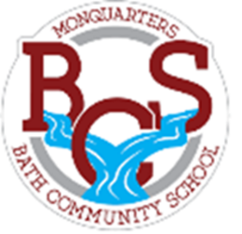
Monquarter Memo
Phone: 278-6000 Twitter: @BathMonquarters
Website: http://BCS.nbed.nb.ca/
Upcoming: BCS’s Triple “C” Competition! (Cardboard Classic Creations)
Friday, February 12th  Valentine exchange for K-5  Monday, February 15th  Family Day – No School  Friday, February 19th  100th Day of School (tentatively)  Monday, February 22nd  Monquarter Monday: Wear your K.I.D.S. shirt, BCS clothing or school colors.  Tuesday, February 23rd  Twin Day: Find a pal or pals to match with.  Wednesday, February 24th  Pink Day (Anti-Bullying Day): Wear pink to show your support.  Thursday, February 25th  That’s Wild Thursday: Show us your wild and creative hair styles.  Friday, February 26th  Feel Good Friday: Wear your PJ’s, slippers or favourite cozy outfit.  March 1st – 5th  March Break  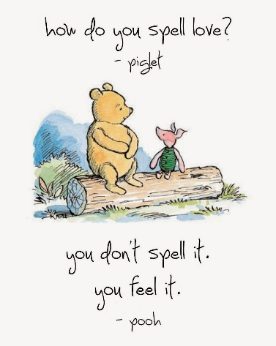  Students still need  each day:  - two clean masks  - a clean water bottle  - warm, dry clothes for outdoor recess and/or Phys. Ed. |  |  |  |  | As part of a school-wide initiative to encourage teamwork and creativity,  each class will be divided into groups to design and build their own cardboard sled creation. Students will be given one role of duct-tape per group to assist in building a cardboard creation they believe will be durable in design and function as a true sled on snow.  Groups must draw a plan on paper first, and class time will then be provided to build the sled. They will be driven down a local hill, by one member of the group (driver must wear a helmet) to see how well they work, to test their durability and to gauge their speed.  We will ‘race’ the sleds the week of February 16th. The day will be dependent on weather.  Students are already enjoying planning and preparing their sleds – ask them about it!
SKATING
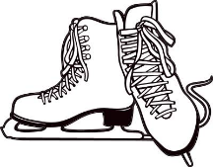
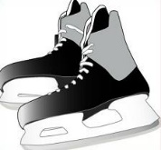
We are so fortunate to have an outdoor rink in our community! Many students will be taking advantage of it with Phys. Ed classes over the coming weeks. Students will be told the day before going so they can be prepared.
Helmets are required (Hockey, ski or multi-sport). If your child does not have skates, please let their teacher know. We will do our best to have all students enjoying the rink!

